Automobilia's Miss Moonlight Pin-up Contest
*”This contest will be held during the Automobilia’s Car Moonlight Car Show  Saturday  Pre-Registration - $20 ENTRY  July 11, 2020  MUST BE AT LEAST 18 YEARS OLD TO PARTICIPATE  5pm-9pm  VINTAGE PIN-UP GIRL ATTIRE REQUIRED  Downtown Wichita, Kansas | 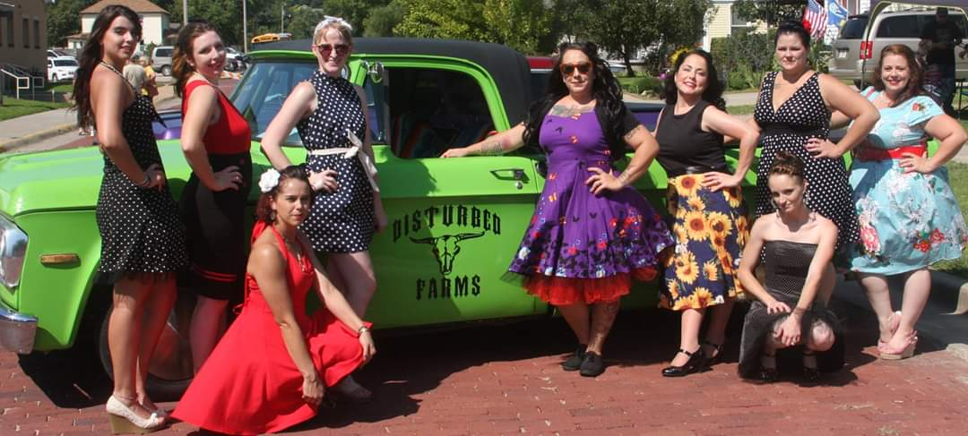

ABSOLUTELY NO: *NUDITY *SWIMSUITS *LINGERIE WORN AS OUTERWEAR OR *INAPPROPRIATE OUTFITS

The Rules:

All participants are encouraged to be at check-in no later than 5p.m. There will be prizes for the Top 3 girls will be awarded prizes. Contestants must be dressed in 40’s to 60’s Pin-up Girl fashion. Contestants will be judged on make, hair, attire, stage presence, approachability & timeliness. Participants will be disqualified for any violation of contest rules.

Please fill out and email registration form to darla.depaine@gmail.com before June 28, 2020.

Automobilia’s Moonlight Pin-up GIRL Contest!!

Name _________________________________________________________________________________________

Pin-Up Name: ___________________________________________________________________________________

Address ________________________________________ City _______________ ST ___________ Zip ___________

Phone ________________________________________ Email address ____________________________________
I agree to NOT hold Sunflower Pin-up, Automobilia Committee or City of Wichita and its volunteers responsible for any liability that may occur. I agree to allow my image to be used in promotional material. I understand that there will be absolutely NO: Nudity, Swimsuit, and Lingerie worn as outerwear or Inappropriate outfits as this is a family event. Participants will be disqualified for any violation of contest rules.
I certify that I am at least 18 years of age and am eligible to participate in this contest. I understand that a non-refundable payment of $20, a photo and registration paperwork is to be turned in to darla.depaine@gmail.com or before June 27, 2020. for official entry. I also understand that by signing below, I am agreeing to these terms.

Signature ________________________________________________________ Date____________

